**INPUT**

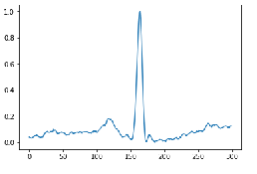

**HIDDEN1(Convolutional)**

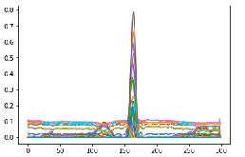

**HIDDEN2(MaxPooling)**

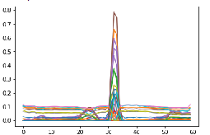

**HIDDEN3(Convolutional)**

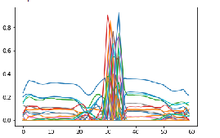

**HIDDEN4(MaxPooling)**

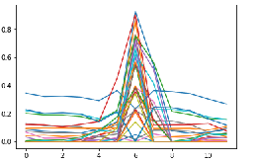

**HIDDEN5(Convolutional)**

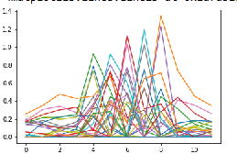

**HIDDEN6(Maxpooling)**

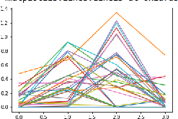

**HIDDEN7(Convolutional)**

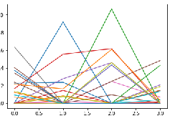

**HIDDEN8(Upsampling)**

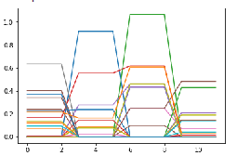

**HIDDEN9(convolutional)**

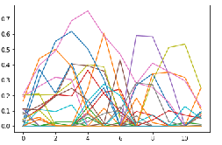

**HIDDEN10(upsampling)**

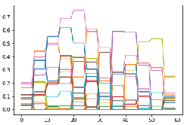

**HIDDEN11(convolutional)**

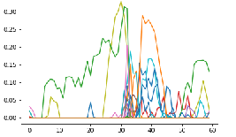

**HIDDEN12(upsampling)**

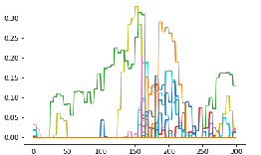

**OUT(convolutional)**

